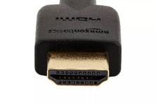
FOR COMPUTER:
*If your computer does not have an HDMI input, you will need an adapter*
- Turn on projector
- Plug HDMI into computer
- Use Gefen Switcher to select COMP input by using the INPUT button
FOR DOCUMENT CAMERA:
- Turn on Projector
- Use Gefen Switcher to select DOC input by using the INPUT button
For Auxiliary Cable to Play Music:
*If your computer does not play audio through HDMI, use Aux cable*
- Plug auxiliary cable into computer or phone
- Use Gefen Switcher to select AUX input by using the INPUT button
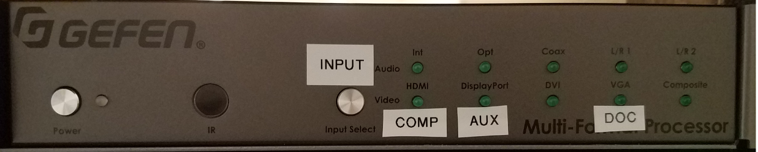

To Adjust Microphone Volume
- Check that the MASTER volume knob is turned up (Master controls all)
- Adjust MIC 1 by turning the MIC 1 volume knob
- Adjust MIC 2 by turning the MIC 2 volume knob
*No more than half volume should be needed on any of the dials
To Adjust Computer or Music Volume
- Check that the MASTER volume knob is turning up (Master controls all)
- Adjust computer volume or music volume by turning the MEDIA volume knob

